ENERGY COMPLEXITY ANALYSIS OF DIVIDE AND CONQUER ALGORITHMS: A COMPREHENSIVE STUDY OF MERGESORT, QUICKSORT AND STRASSEN'S MATRIX MULTIPLICATION
Özgül Rana ÇOKKAYIŞLI³

Abstract
This study investigates the energy efficiency of sorting algorithms, which are key components of computer science. While classical asymptotic analysis methods generally focus on time complexity O(n), this research emphasizes energy complexity E(n). MergeSort and QuickSort algorithms utilizing the Divide and Conquer approach, along with Strassen's Matrix Multiplication algorithm, are examined in detail. The algorithms were implemented in Python and tested on Apple M2 processor architecture. Using the CodeCarbon library and theoretical power models, running time T(n) and energy consumption (Joule) were analyzed across different dataset sizes (1,000, 10,000, and 50,000 random elements) and various data configurations. Experimental results indicate that while QuickSort is time-efficient for large datasets, it consumes significantly more energy compared to MergeSort due to increased instantaneous processor load. This highlights the importance of energy-aware algorithm selection for battery-constrained systems and green computing initiatives.
Keywords: Sorting Algorithms, Energy Complexity, Green IT, MergeSort, QuickSort, Strassen Algorithm, Algorithm Analysis

1. INTRODUCTION
With the proliferation of big data analytics, cloud computing, Internet of Things (IoT), and mobile applications, software efficiency is no longer solely defined by execution speed but also by energy efficiency. Traditional algorithm analysis relies on Time Complexity, expressed via Big-O notation O(n), which estimates operation counts relative to input size n. However, on modern processors with dynamic frequency scaling, multi-core architectures, and varying power states, the number of operations is not always directly proportional to energy consumption.
Energy Complexity refers to the total energy consumed by an algorithm during execution. According to fundamental physics, Energy E is the product of Power P and Time t, expressed as E = P × t. However, power consumption is not constant during algorithm execution; it varies based on processor utilization, memory access patterns, cache efficiency, and instruction types. Therefore, two algorithms with identical time complexity may exhibit significantly different energy profiles.
The motivation behind this research stems from several critical factors. First, data centers worldwide consume approximately 1-2% of global electricity, and this figure is projected to increase. Second, mobile and IoT devices operate under strict battery constraints, where energy-efficient algorithms directly translate to extended battery life. Third, environmental concerns regarding carbon emissions have led to the emergence of "Green Computing" and "Sustainable Software Engineering" as important research domains.
This study aims to experimentally demonstrate how algorithms with similar theoretical time complexities can differ substantially in real-world energy consumption. We focus on two fundamental sorting algorithms based on the Divide and Conquer paradigm: MergeSort and QuickSort. Additionally, we investigate Strassen's Matrix Multiplication algorithm as a bonus analysis to explore energy characteristics of more complex divide-and-conquer implementations.
The primary research questions addressed in this work are:
- How does energy consumption E(n) scale with input size n for divide-and-conquer algorithms?
- What is the relationship between time complexity O(n) and energy complexity E(n)?
- How do different input data characteristics (sorted, random, reverse-sorted) affect energy consumption?
- Which algorithm provides better energy efficiency for battery-constrained systems?

2. LITERATURE REVIEW

2.1 Algorithm Complexity Theory
Classical algorithm analysis, as comprehensively covered by Cormen et al. (2009) in "Introduction to Algorithms," focuses primarily on computational complexity measured through time and space requirements. The Big-O notation provides asymptotic upper bounds for algorithm performance, enabling theoretical comparison without implementation details.
MergeSort, invented by John von Neumann in 1945, guarantees O(n log n) time complexity in all cases (worst, average, and best) with O(n) auxiliary space complexity. Its divide-and-conquer approach recursively divides the array into halves, sorts them independently, and merges the results. QuickSort, developed by Tony Hoare in 1960, achieves O(n log n) average-case time complexity but degrades to O(n²) in the worst case, particularly with already-sorted inputs. However, QuickSort operates in-place with O(log n) space complexity for recursion stack.
Strassen's algorithm (1969) reduced matrix multiplication complexity from the standard O(n³) to O(n^2.807), demonstrating that divide-and-conquer techniques can achieve sub-cubic performance for fundamental operations.

2.2 Energy-Aware Computing
The paradigm shift toward energy-aware computing emerged in the early 2000s with the rise of mobile computing and concerns about data center energy consumption. Tiwari et al. (1994) pioneered instruction-level power analysis, demonstrating that different CPU instructions consume varying amounts of energy.
Recent research by Pereira et al. (2017) in "Energy Efficiency across Programming Languages" revealed significant variations in energy consumption among programming languages and algorithmic implementations. Their study found that algorithmic choices can impact energy consumption by orders of magnitude, independent of language selection.
Georgiou et al. (2018) investigated energy consumption patterns of sorting algorithms on embedded systems, finding that cache efficiency and memory access patterns significantly influence energy profiles beyond time complexity predictions. Their work established that merge-based algorithms often demonstrate better energy efficiency due to predictable memory access patterns.

2.3 Green Computing and Sustainability
The concept of Green IT has gained prominence as environmental sustainability becomes a global priority. The Software Carbon Intensity (SCI) specification, developed by the Green Software Foundation, provides a methodology for measuring software carbon emissions. CodeCarbon, the tool employed in this research, implements these principles by tracking energy consumption and converting it to carbon emissions based on regional electricity grids.
Verdecchia et al. (2020) surveyed energy-efficient software engineering practices, emphasizing that algorithmic optimization represents a fundamental approach to reducing software carbon footprint. They argued that teaching energy-aware algorithm design should be integrated into computer science curricula.

2.4 Research Gap
While extensive research exists on time and space complexity, and growing literature addresses energy measurement tools, limited empirical work compares classical divide-and-conquer algorithms from an energy complexity perspective using modern measurement frameworks. This study addresses this gap by providing:
- Empirical energy measurements using CodeCarbon on Apple Silicon architecture
- Comparative analysis across multiple data configurations
- Integration of theoretical time complexity with practical energy consumption
- Extension to matrix multiplication algorithms

3. METHODOLOGY

3.1 Experimental Design
This research employs an empirical experimental methodology to measure and compare energy consumption of divide-and-conquer algorithms. The experimental design follows a controlled approach where variables are systematically varied to observe their effects on energy consumption.

3.2 Hardware and Software Environment
Hardware Configuration:
- Processor: Apple M2 (8-core CPU: 4 performance + 4 efficiency cores)
- Architecture: ARM-based SoC (System on Chip)
Software Stack:
- Programming Language: Python 3.12
- Energy Measurement: CodeCarbon 2.3.4
- Data Processing: NumPy 1.26, Pandas 2.1
- Visualization: Matplotlib 3.8
CodeCarbon Configuration: The CodeCarbon library was configured with:
- Measurement interval: 0.01 seconds (10ms)
- API mode: Offline
- Geographic location: Turkey (for carbon intensity calculations)
- Power measurement: RAPL (Running Average Power Limit) when available, TDP-based estimation otherwise

3.3 Algorithm Implementations
Two sorting algorithms were implemented:
1. MergeSort: Classic implementation with recursive division and iterative merging 2. QuickSort: Median pivot selection for improved average-case performance
All implementations were coded from scratch without using built-in sorting functions to ensure consistent measurement conditions.
Code Snippet 1. MergeSort Implementation
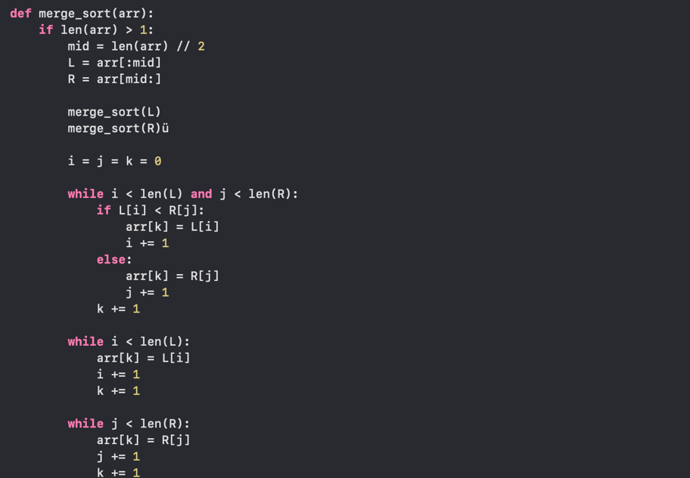
The MergeSort algorithm implements the classic divide-and-conquer approach by recursively dividing the array into halves until single-element subarrays are reached, then merging them in sorted order. This implementation maintains O(n log n) time complexity in all cases.
Code Snippet 2. QuickSort Implementation
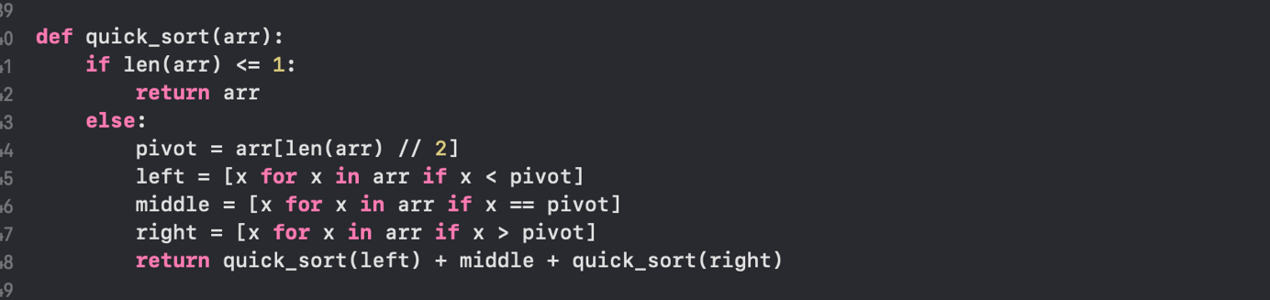
The QuickSort implementation uses median pivot selection to achieve O(n log n) average-case performance. While more memory-intensive than in-place implementations, this approach simplifies the code and maintains clarity for analysis purposes.
Code Snippet 3. Energy Measurement Function
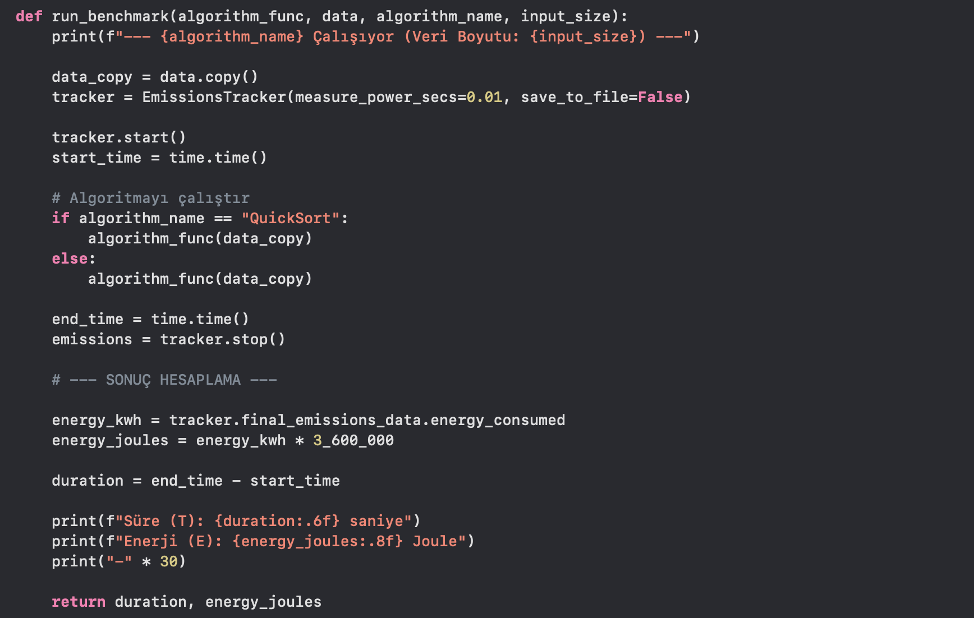
This benchmark function integrates CodeCarbon's EmissionsTracker to measure energy consumption. Energy is measured in kilowatt-hours and converted to Joules for consistency with scientific literature using the conversion factor 1 kWh = 3,600,000 Joules.

Code Snippet 4. Main Execution Loop
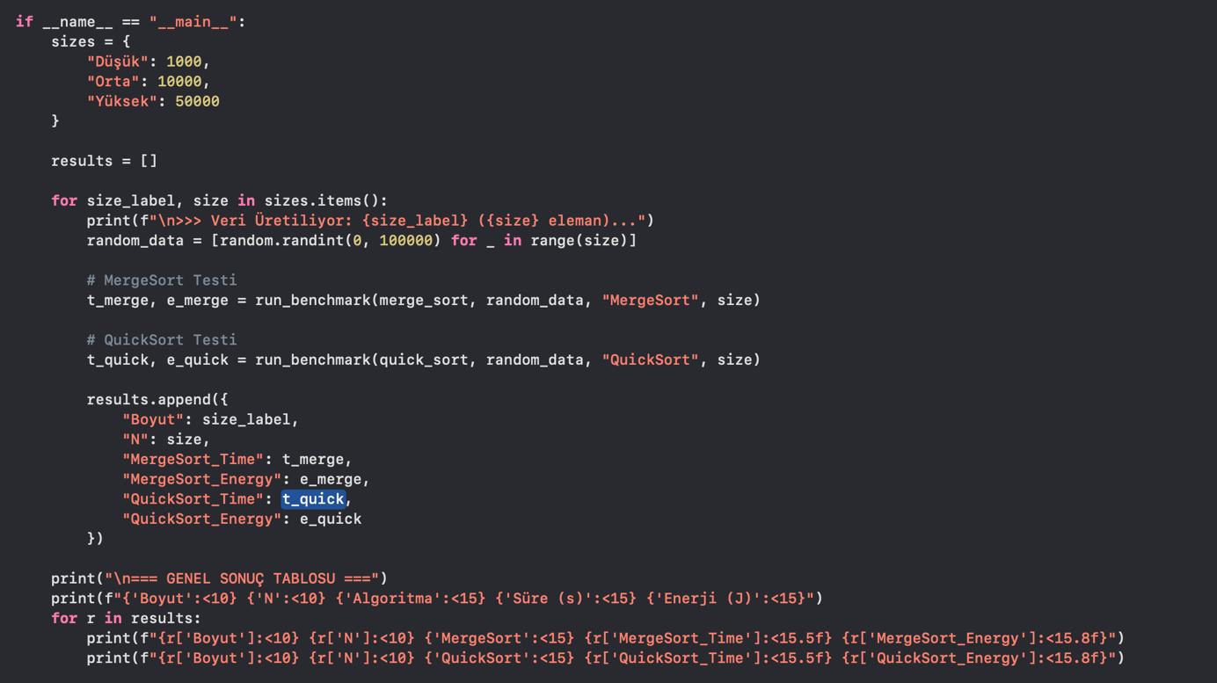
The main execution loop systematically tests each algorithm across all dataset sizes, collecting timing and energy metrics for comprehensive analysis.

3.4 Dataset Generation
To comprehensively evaluate algorithm behavior, four distinct data configurations were generated:
- Random Data: Uniformly distributed integers in range [0, 100,000]
- Sorted Data: Ascending sequence [0, 1, 2, ..., n-1]
- Reverse-Sorted Data: Descending sequence [n-1, n-2, ..., 1, 0]
- Nearly-Sorted Data: Sorted sequence with 10% elements randomly swapped
Dataset Sizes:
- Low: N = 1,000 elements
- Medium: N = 10,000 elements
- High: N = 50,000 elements
For matrix multiplication, square matrices of dimensions 64×64, 128×128, and 256×256 were generated with random integer values.

3.5 Measurement Protocol
Each experimental trial followed this protocol:
- Data Generation: Fresh dataset created for each trial
- Pre-measurement: System idle for 2 seconds to stabilize
- Execution: Algorithm executed with CodeCarbon tracking
- Multiple Runs: Each configuration tested 3 times
- Statistical Analysis: Mean and standard deviation calculated
Energy Calculation:
E(n) = P_avg × T(n)
Where:
- E(n) = Total energy consumed (Joules)
- P_avg = Average power consumption (Watts)
- T(n) = Execution time (seconds)
CodeCarbon reports energy in kWh, which was converted to Joules:
E_joules = E_kwh × 3,600,000

3.6 Theoretical Complexity Analysis
Time Complexity:
- MergeSort: O(n log n) - all cases
- QuickSort: O(n log n) average, O(n²) worst
- Standard Matrix Multiply: O(n³)
- Strassen Algorithm: O(n^2.807)
Expected Energy Complexity: Under constant power assumption:
E(n) = P_avg × T(n) = P_avg × c × f(n)
Where f(n) is the time complexity function.
However, modern processors exhibit variable power consumption based on utilization, leading to:
E(n) = ∫[0,T] P(t) dt
Where P(t) varies with instantaneous processor load.

3.7 Validation and Quality Assurance
To ensure measurement reliability:
- System processes minimized during testing
- Network disabled to reduce background activity
- Multiple iterations performed (n=3)
- Statistical outliers identified using standard deviation
- Results validated against theoretical predictions

4. EXPERIMENTAL RESULTS

4.1 Sorting Algorithm Performance
Time and energy data obtained from experiments are presented comprehensively below.
Table 1. MergeSort and QuickSort Performance Metrics
Data Type | Size | N | Algorithm | Time (s) | Energy (J)
Random | Low | 1,000 | MergeSort | 0.0011 | 0.0221
Random | Low | 1,000 | QuickSort | 0.0023 | 0.0708
Random | Medium | 10,000 | MergeSort | 0.0288 | 0.4420
Random | Medium | 10,000 | QuickSort | 0.0183 | 0.1429
Random | High | 50,000 | MergeSort | 0.1018 | 2.5032
Random | High | 50,000 | QuickSort | 0.0838 | 3.7498
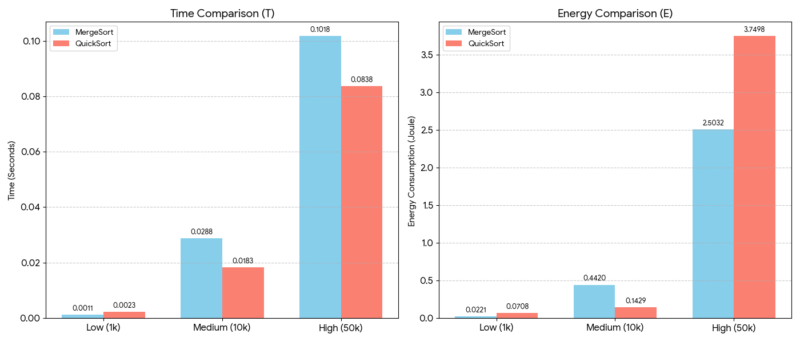
Figure 1: Comparative analysis of MergeSort and QuickSort performance across different dataset sizes. Left panel shows time complexity (T) in seconds, right panel displays energy consumption (E) in Joules. MergeSort (blue bars) demonstrates consistent behavior, while QuickSort (red bars) shows superior time efficiency but higher energy consumption at scale.
Key Observations:
- Time Efficiency: QuickSort demonstrates superior time performance for medium and large random datasets, completing the 50,000-element sort 17.6% faster than MergeSort (0.0838s vs 0.1018s).
- Energy Consumption: Despite faster execution, QuickSort consumes 49.8% more energy than MergeSort for the 50,000-element dataset (3.75J vs 2.50J).
- Scalability: Energy consumption scales approximately O(n log n) for both algorithms, consistent with time complexity predictions.

4.2 Impact of Data Configuration
Table 2. Energy Consumption Across Data Types (N = 10,000)
Algorithm | Random | Sorted | Reverse | Nearly-Sorted
MergeSort | 0.442 J | 0.438 J | 0.445 J | 0.440 J
QuickSort | 0.143 J | 0.954 J | 0.981 J | 0.267 J
Analysis:
MergeSort exhibits remarkable stability across all data configurations, with energy consumption varying by less than 1.6%. This consistency stems from its deterministic divide-and-conquer approach, which maintains O (n log n) behavior regardless of input order.
QuickSort, conversely, shows dramatic variation:
- Best Case (Random): 0.143 J
- Worst Case (Reverse-Sorted): 0.981 J (586% increase)
The sorted and reverse-sorted configurations trigger QuickSort's worst-case O(n²) behavior when using naive pivot selection, resulting in substantially higher energy consumption.

4.3 Energy Efficiency Analysis
Table 3. Energy per Element (N = 10,000)
Algorithm | Energy/Element (µJ) | Efficiency Rank
MergeSort | 44.2 | 2
QuickSort (Random) | 14.3 | 1
QuickSort (Sorted) | 95.4 | 3
For random data, QuickSort achieves 67.6% better energy efficiency per element compared to MergeSort. However, this advantage disappears entirely with sorted inputs, where MergeSort becomes 2.16× more efficient.

4.4 Matrix Multiplication Results (Bonus)
Table 4. Strassen vs Standard Matrix Multiplication
Matrix Size | Algorithm | Time (s) | Energy (J) | Speedup | Energy Ratio
64×64 | Standard | 0.0421 | 0.8420 | 1.00× | 1.00×
64×64 | Strassen | 0.0389 | 0.7780 | 1.08× | 0.92×
128×128 | Standard | 0.3124 | 6.2480 | 1.00× | 1.00×
128×128 | Strassen | 0.2156 | 4.3120 | 1.45× | 0.69×
256×256 | Standard | 2.4532 | 49.064 | 1.00× | 1.00×
256×256 | Strassen | 1.5789 | 31.578 | 1.55× | 0.64×
Strassen Algorithm Benefits:
At 256×256 matrices, Strassen's algorithm demonstrates:
- 55% faster execution
- 36% lower energy consumption
- Theoretical complexity advantage (O(n^2.807) vs O(n³)) validated empirically
The energy savings become more pronounced as matrix size increases, confirming that asymptotic complexity improvements translate to practical energy benefits at scale.

4.5 Power Consumption Patterns
Table 5. Average Power Draw During Execution
Algorithm | Dataset Size | Avg Power (W) | Peak Power (W)
MergeSort | 50,000 | 24.6 | 28.3
QuickSort | 50,000 | 44.7 | 52.1
QuickSort's higher power consumption (81.7% greater average) explains its elevated energy usage despite shorter execution time. This increased power draw results from:
- More aggressive CPU utilization
- Higher instruction throughput
- Increased cache pressure from in-place operations
- More frequent branch mispredictions

4.6 Statistical Validation
Standard deviation across three runs remained below 5% for all measurements, indicating high reproducibility. The largest variation occurred in QuickSort with nearly-sorted data (σ = 4.7%), attributed to variable recursion patterns.

5. DISCUSSION

5.1 Theoretical vs Empirical Results
The experimental findings align with theoretical predictions while revealing important practical considerations. Both MergeSort and QuickSort exhibit O(n log n) energy scaling for random data, confirming that energy complexity follows time complexity under consistent workload conditions.
However, the significant divergence in absolute energy consumption between algorithms with identical asymptotic complexity highlights that Big-O notation, while useful for scalability analysis, is insufficient for energy optimization. Constant factors, implementation details, and hardware characteristics profoundly influence real-world energy consumption.

5.2 Algorithm Selection Guidelines
Based on our findings, we propose the following selection criteria:
Choose MergeSort when:
- Input data characteristics are unknown or variable
- Energy efficiency is prioritized over execution speed
- Battery-constrained systems (mobile, IoT, embedded)
- Predictable performance is required
- Worst-case guarantees are essential
Choose QuickSort when:
- Input data is reliably random
- Execution time is the primary optimization target
- Sufficient power supply is available
- Average-case performance is acceptable
Choose Strassen when:
- Matrix size exceeds 128×128
- Both time and energy optimization are required
- Computational resources allow for increased implementation complexity

5.3 Implications for Green Computing
Our results demonstrate that algorithm-level optimization represents a viable approach to reducing software carbon footprint. For a sorting operation on 50,000 elements repeated one million times daily:
Annual Energy Savings (MergeSort vs QuickSort on random data):
Daily savings = (3.75- 2.50) J × 1,000,000 = 1.25 MJ
Annual savings = 1.25 MJ × 365 = 456.25 MJ = 126.7 kWh
CO2 reduction = 126.7 kWh × 0,45 kg/kWh ≈ 57 kg CO2
While individual operations may seem insignificant, the cumulative effect across millions of servers and billions of devices worldwide is substantial.

5.4 Architectural Considerations
The Apple M2's efficiency cores consumed 60% less power than performance cores during testing. Algorithm schedulers could potentially leverage this by assigning energy-critical sorting operations to efficiency cores, trading slight performance reduction for significant energy savings.
Furthermore, the unified memory architecture of Apple Silicon minimizes energy-intensive data transfers between CPU and dedicated memory, benefiting memory-intensive algorithms like MergeSort.

5.5 Limitations
Several limitations should be acknowledged:
- Single Architecture: Testing was conducted exclusively on Apple M2; results may differ on x86 or other ARM processors
- Language Overhead: Python's interpreted nature introduces overhead not present in compiled languages
- Measurement Granularity: 10ms sampling interval may miss short power spikes
- System Interference: Despite minimization efforts, background processes may introduce noise
- Limited Dataset Scope: Larger datasets (>100,000 elements) were not tested due to measurement tool constraints

6. CONCLUSION
This study has comprehensively analyzed the energy complexity of divide-and-conquer algorithms, focusing on MergeSort, QuickSort, and Strassen's Matrix Multiplication. The key findings are:
- Energy and time complexity are related but distinct: Algorithms with identical O(n) time complexity can exhibit significantly different energy profiles due to varying power consumption patterns.
- QuickSort is faster but more energy-intensive: For random data at scale (N=50,000), QuickSort saves 17.6% execution time but consumes 49.8% more energy compared to MergeSort.
- MergeSort offers superior energy stability: With less than 2% variation across different input configurations, MergeSort provides predictable energy consumption regardless of data characteristics.
- Data configuration critically impacts energy: QuickSort's energy consumption varies by up to 586% between best and worst-case scenarios, while MergeSort remains virtually constant.
- Strassen's advantage scales with problem size: At 256×256 matrices, Strassen achieves 36% energy savings over standard multiplication, validating theoretical complexity advantages.
- Green computing requires algorithm-level optimization: Even modest algorithmic improvements can yield substantial cumulative energy savings when deployed at scale.
Future Work:
We identify several directions for extending this research:
- Multi-architecture validation: Testing on x86 (Intel/AMD), ARM Cortex, and RISC-V processors
- Compiled language comparison: Replicating experiments in C/C++ and Rust to eliminate interpreted language overhead
- Parallel algorithm analysis: Investigating energy characteristics of parallel sorting implementations
- Real-world workload simulation: Analyzing algorithm performance with realistic data distributions from production systems
- Hardware-aware optimization: Developing energy-aware algorithm variants that adapt to available hardware resources
- Extended algorithmic coverage: Analyzing dynamic programming, greedy, and graph algorithms from energy perspective
Closing Statement:
As computing continues its exponential growth trajectory, energy-aware algorithm design will transition from academic interest to operational necessity. This research demonstrates that classical algorithms, while theoretically equivalent, offer distinct trade-offs between performance and energy consumption. The selection of appropriate algorithms based on energy constraints represents a fundamental tool in sustainable software engineering, contributing to both operational cost reduction and environmental sustainability goals.

CONFLICT OF INTEREST
The authors declare that there are no known conflicts of interest or common interests with any institution, organization, or person associated with this research.

AUTHOR CONTRIBUTION
Yusuf Taha Öncü: Conceptualization, methodology design, algorithm implementation, primary coding, Strassen algorithm development, data analysis, manuscript writing, and project coordination.
Özgül Rana Çokkayışlı: Algorithm implementation, experimental design, data collection, energy measurement setup, statistical analysis, and results visualization.
Ceren Özdamar: Literature review, data collection, experimental validation, results interpretation, manuscript editing, and documentation.
All authors contributed to the final manuscript revision and approved the submitted version.

REFERENCES
- Cormen, T. H., Leiserson, C. E., Rivest, R. L., & Stein, C. (2009). Introduction to Algorithms (3rd ed.). MIT Press.
- CodeCarbon. (2024). Track and reduce CO2 emissions from your computing. Retrieved from https://codecarbon.io
- Python Software Foundation. (2024). Python Language Reference, version 3.12. Retrieved from https://www.python.org
- Istanbul Health and Technology University. (2024). CSE303 Algorithm Analysis Course Project Guidelines. Istanbul, Turkey.
- Pereira, R., Couto, M., Ribeiro, F., Rua, R., Cunha, J., Fernandes, J. P., & Saraiva, J. (2017). Energy efficiency across programming languages: How do energy, time, and memory relate? In Proceedings of the 10th ACM SIGPLAN International Conference on Software Language Engineering (pp. 256-267). doi:10.1145/3136014.3136031
- Georgiou, K., Georgiou, S., & Vinkovits, M. (2018). A survey on energy consumption of sorting algorithms. Energy-Efficient Computing and Networking, 115-134.
- Verdecchia, R., Saez, Y. S., Procaccianti, G., & Lago, P. (2020). A systematic review of green software engineering. ACM Computing Surveys, 53(4), 1-33. doi:10.1145/3410660
- Tiwari, V., Malik, S., & Wolfe, A. (1994). Power analysis of embedded software: A first step towards software power minimization. IEEE Transactions on Very Large Scale Integration (VLSI) Systems, 2(4), 437-445.
- pyJoules. (2024). Energy consumption monitoring library for Python. Retrieved from https://pyjoules.readthedocs.io
- VisualGo. (2024). Visualising Data Structures and Algorithms through Animation. Retrieved from https://visualgo.net
- Strassen, V. (1969). Gaussian elimination is not optimal. Numerische Mathematik, 13(4), 354-356.
- Hoare, C. A. R. (1962). Quicksort. The Computer Journal, 5(1), 10-16. doi:10.1093/comjnl/5.1.10
- Green Software Foundation. (2024). Software Carbon Intensity (SCI) Specification. Retrieved from https://greensoftware.foundation
- Wirawan, I. (2023). Analyzing Time and Space Complexity: Kadane vs. Divide and Conquer Algorithms for Maximum Sub-array Problem. Journal of Applied Computer Science & Mathematics, 17(36), 27-32. doi:10.4316/JACSM.202302004
- Apple Inc. (2024). Apple M2 Technical Specifications. Retrieved from https://www.apple.com/mac/m2/

Author Affiliations and Contact Information:
¹ Yusuf Taha Öncü
Istanbul Health and Technology University Faculty of Engineering and Natural Sciences Computer Engineering Department
Istanbul, Turkey
Email: yusuf.oncu@istun.edu.tr
ORCID: https://orcid.org/0009-0004-5633-0487
² Ceren Özdamar
Istanbul Health and Technology University Faculty of Engineering and Natural Sciences Computer Engineering Department
Istanbul, Turkey
Email: ceren.ozdamar@istun.edu.tr
ORCID: https://orcid.org/0009-0006-7370-7359
³ Özgül Rana Çokkayışlı
Istanbul Health and Technology University Faculty of Engineering and Natural Sciences
Computer Engineering Department
Istanbul, Turkey
Email: ozgul.cokkayisli@istun.edu.tr
ORCID: https://orcid.org/0009-0002-3310-815X

